**DAILY ONLINE ACTIVITIES SUMMARY**

|  |  |  |  |  |  |  |  |  |
| --- | --- | --- | --- | --- | --- | --- | --- | --- |
| **Date:** | **09-06-2020** | | | | | **Name:** | **Ashwini** | |
| **Sem & Sec** | **A** | | | | | **USN:** | **4AL17CS017** | |
| **Online Test Summary** | | | | | | | | |
| **Subject** | | **CGV** | | | | | | |
| **Max. Marks** | | **30** | | **Score** | | | **27** | |
| **Certification Course Summary** | | | | | | | | |
| **Course** | **INTRODUCTION TO ETHICAL HACKING** | | | | | | | |
| **Certificate Provider** | | | Greatlearning  Academy | | **Duration** | | | 6hours |
| **Coding Challenges** | | | | | | | | |
| **Status: Done** | | | | | | | | |
| **Uploaded the report in Github** | | | | | **YES** | | | |
| **If yes Repository name** | | | | | <https://github.com/ashwiniachar/online-report> | | | |
| **Uploaded the report in slack** | | | | | **YES** | | | |

Online Test Details:

Subject:-CGV.

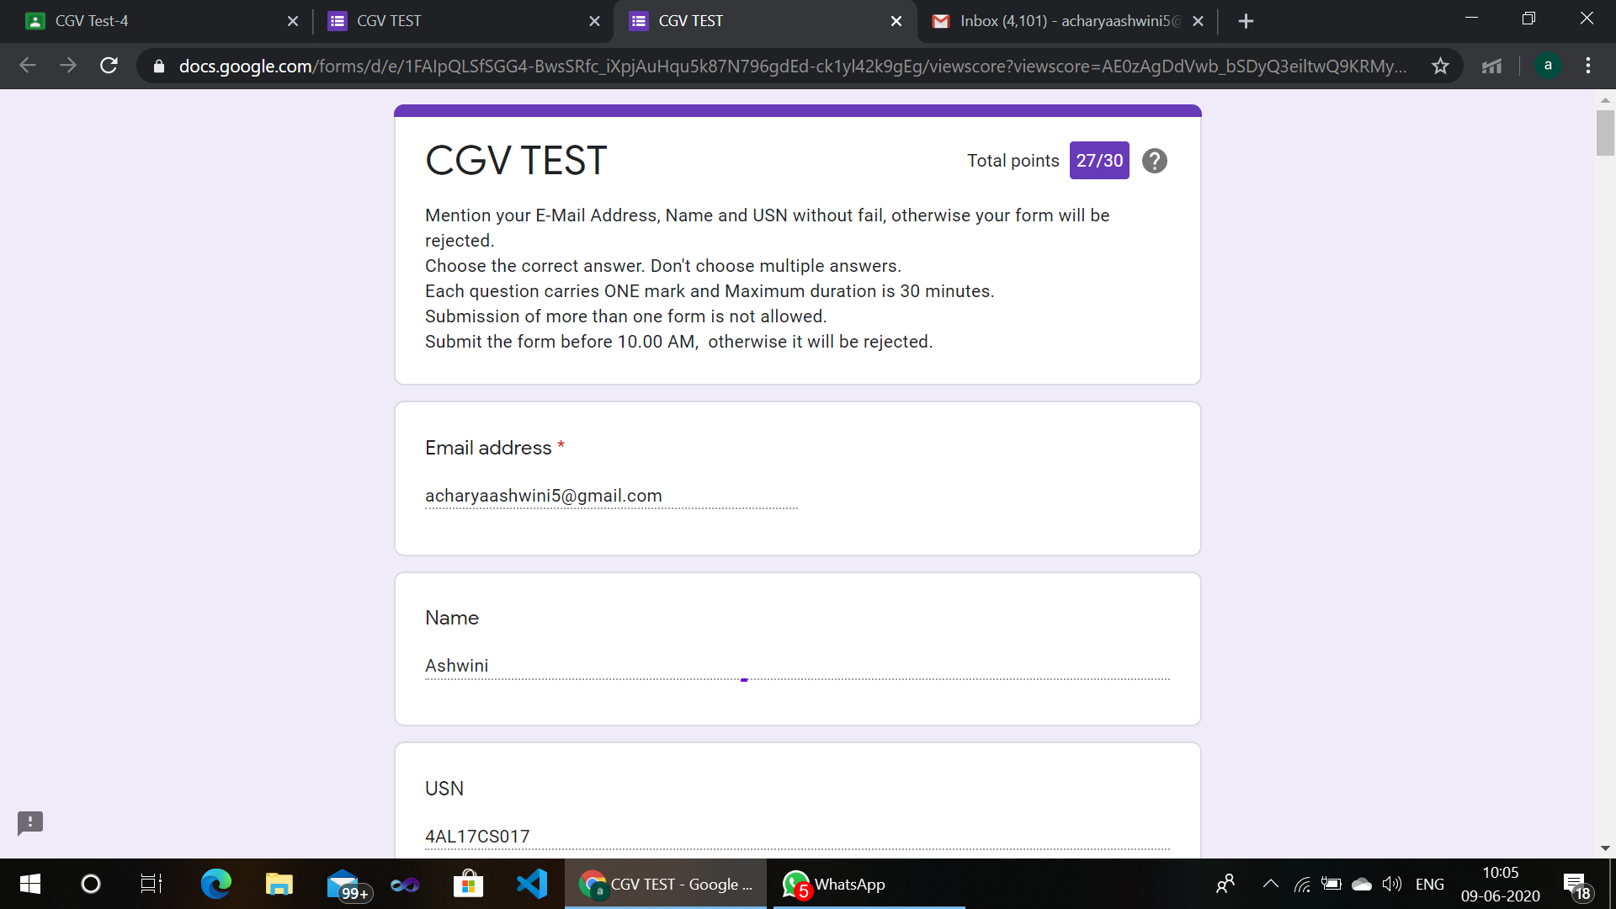CERTIFICATION COURSE:

**Introduction to Ethical Hacking:**

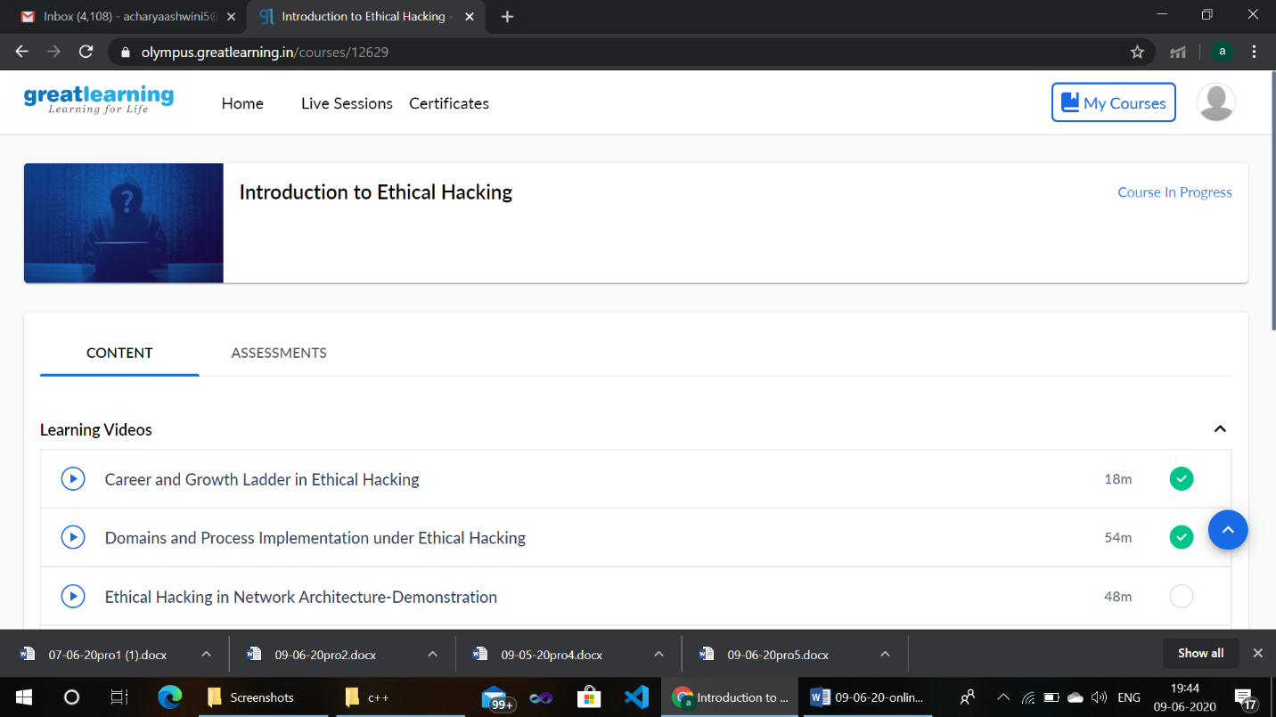

**Coding Challenges Details:**

2. Write a Python to implement Perfect Sum Problem

Given an array arr[] of integers and an integer K, the task is to print all subsets of the given array with the sum equal to the given target K.

Input: arr[] = {5, 10, 12, 13, 15, 18}, K = 30

Output: {12, 18}, {5, 12, 13}, {5, 10, 15}

Explanation:  
Subsets with sum 30 are:  
12 + 18 = 30  
5 + 12 + 13 = 30  
5 + 10 + 15 = 30

def sumSubsets(sets, n, target) :

x = [0]*len(sets);

j = len(sets) - 1;

while (n > 0) :

x[j] = n % 2;

n = n // 2;

j -= 1;

sum = 0;

for i in range(len(sets)) :

if (x[i] == 1) :

sum += sets[i];

if (sum == target) :

print("{",end="");

for i in range(len(sets)) :

if (x[i] == 1) :

print(sets[i],end= ", ");

print("}, ",end="");

def findSubsets(arr, K) :

x = pow(2, len(arr));

for i in range(1, x) :

sumSubsets(arr, i, K);

if __name__ == "__main__" :

arr = [ 5, 10, 12, 13, 15, 18 ];

K = 30;

findSubsets(arr, K);

**output:**

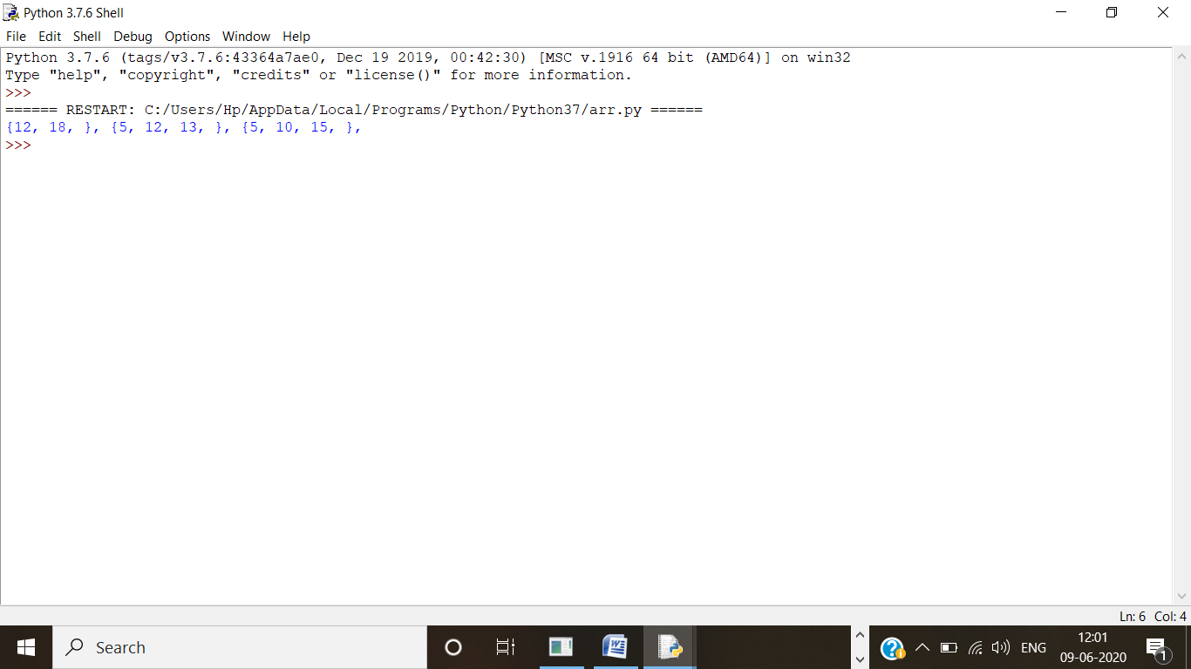

4. Python Program to count even and odd numbers

Write a Python program to count the number of even and odd numbers from a series of numbers.  
Numbers are = (1, 2, 3, 4, 5, 6, 7, 8, 9)  
Output:  
Number of even numbers : 5  
Number of odd numbers : 4

list1 = [1, 2, 3, 4, 5, 6, 7, 8, 9]

even_count, odd_count = 0, 0

for num in list1:

if num % 2 == 0:

even_count += 1

else:

odd_count += 1

print("Even numbers in the list: ", even_count)

print("Odd numbers in the list: ", odd_count)

**output:**

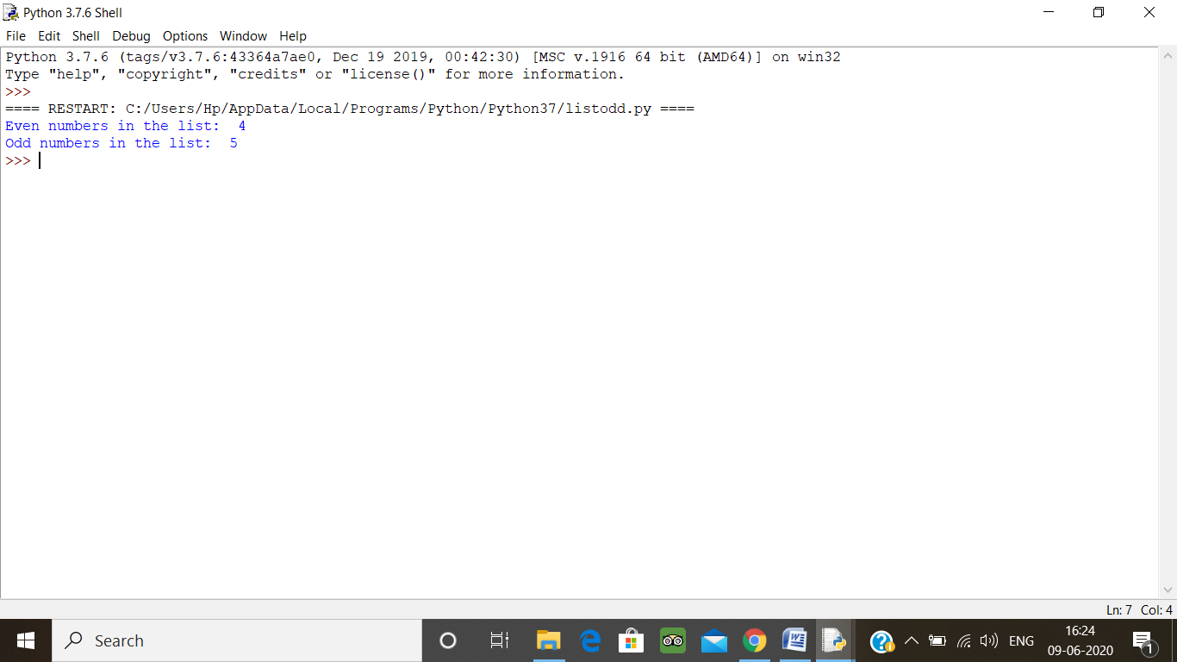

5. Write a Java Program to remove all white spaces from a string without using replace()

public class Main {

public static void main(String[] args) {

String str = "My Name is Anvitha ";

char[] strArray = str.toCharArray();

StringBuffer stringBuffer = new StringBuffer();

for (int i = 0; i < strArray.length; i++) {

if ((strArray[i] != ' ') && (strArray[i] != '\t')) {

stringBuffer.append(strArray[i]);

}

}

String noSpaceStr2 = stringBuffer.toString();

System.out.println(noSpaceStr2);

}

}

**Output:**

